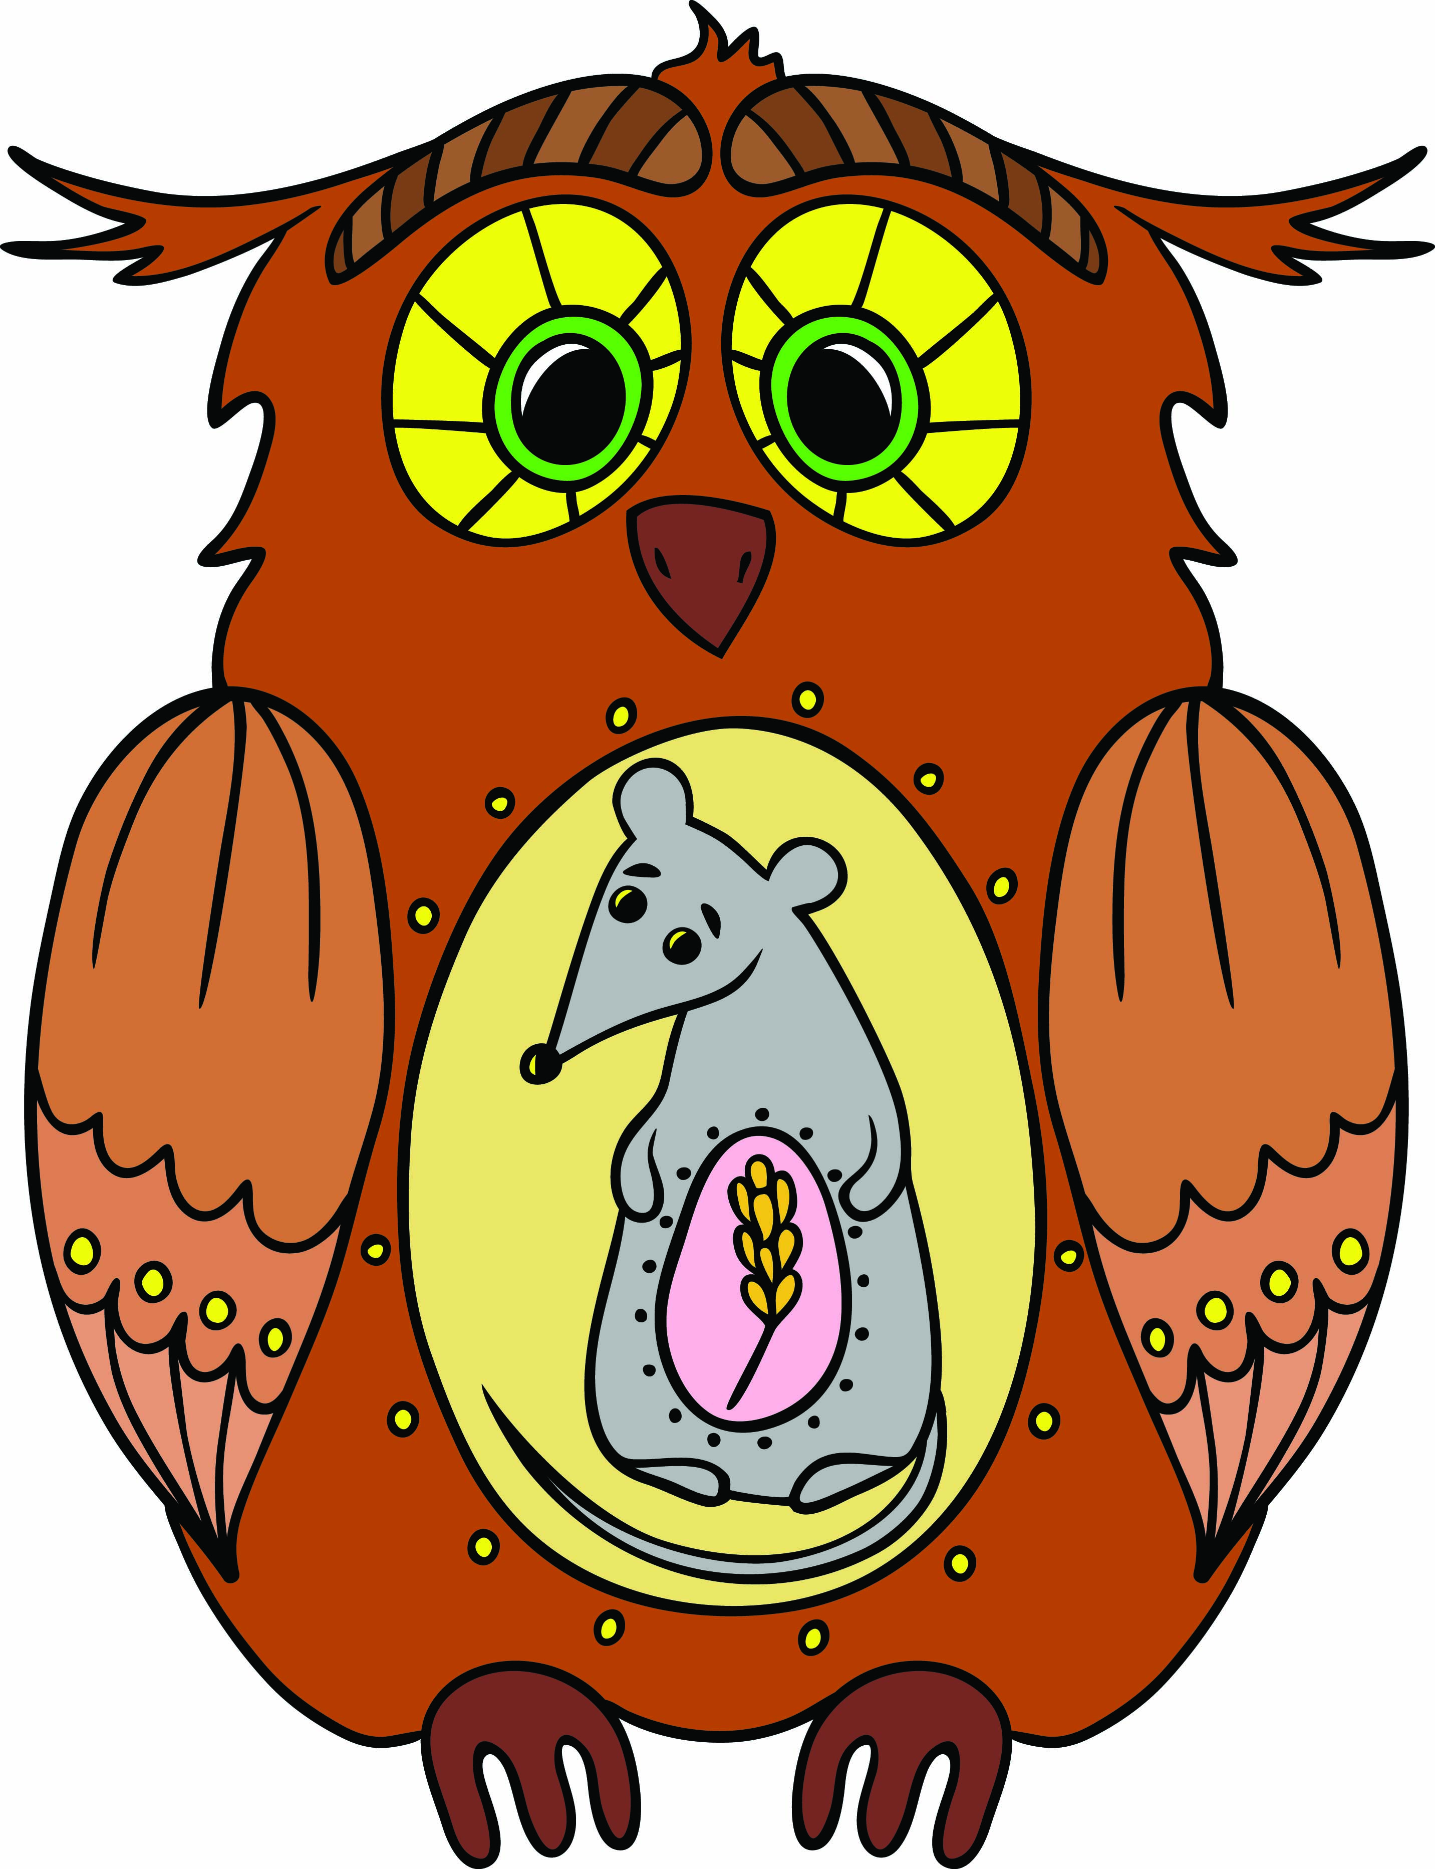Literacy support worksheet

6.1 All organisms are interdependent

Pages 102–103 and 198

Food chains and webs

1 Use the diagram of the owl with the mouse inside its belly and the wheat inside the mouse to construct a food chain. Under each organism in the food chain, write whether they are a consumer or producer.

|  |
| --- |
|  |

2 Could the Sun also be included in a food chain or food web?

3 Draw a diagram showing how food chains work using the following words (refer to Figure 6.4 to help you):

third-order consumer first- order consumer producer second-order consumer

|  |
| --- |
|  |

WORD DETECTIVE

5 Mumbo-jumbo

a Use the marked letters to find the secret word (e.g. olusntoi = solution).

b Unscramble each of the clue words below to find the message.

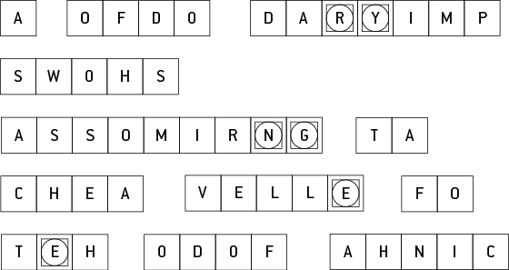

Secret word: __________________________________________________________________________

Message: ____________________________________________________________________________

Literacy support worksheet

6.2 All organisms have a role in an ecosystem

Pages 104–105 and 199

Ecosystems – energy for life

1 Plants are producers that convert the Sun’s energy into food using photosynthesis. Using the information below, label the arrows on the diagram.

In most ecosystems, the Sun provides the energy for the producers.

Producers use this energy during photosynthesis to change the Sun’s energy into food.

During photosynthesis, the sunlight shines on the green leaf, where it converts carbon dioxide and water into sugar and oxygen.

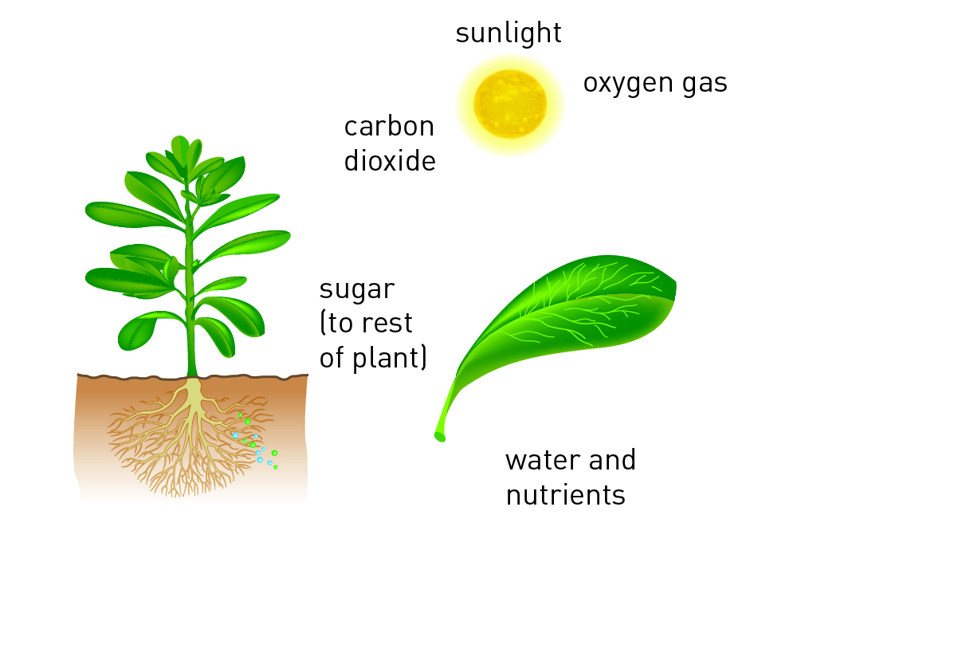

2 Fill in the examples in the flow diagram below.

Decomposers Examples: _______________________________________________

EAT

Consumers (carnivores) Examples: _______________________________________________

EAT

Consumers (herbivores) Examples: _______________________________________________

EAT

Producers (plants) Examples: _______________________________________________

USE

Photosynthesis During photosynthesis, the Sun shines on the green leaf where it converts:

_________________________________________________________

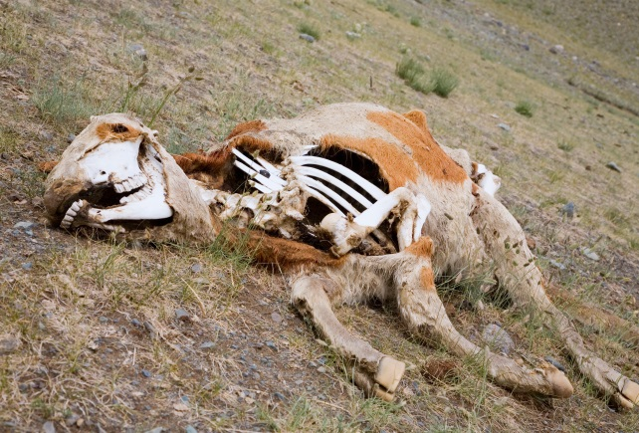3 The cow in the image is in the process of being recycled by decomposers.

Fill in the flow chart and identify whether each living thing is a producer, consumer (herbivore), consumer (carnivore) or decomposer.

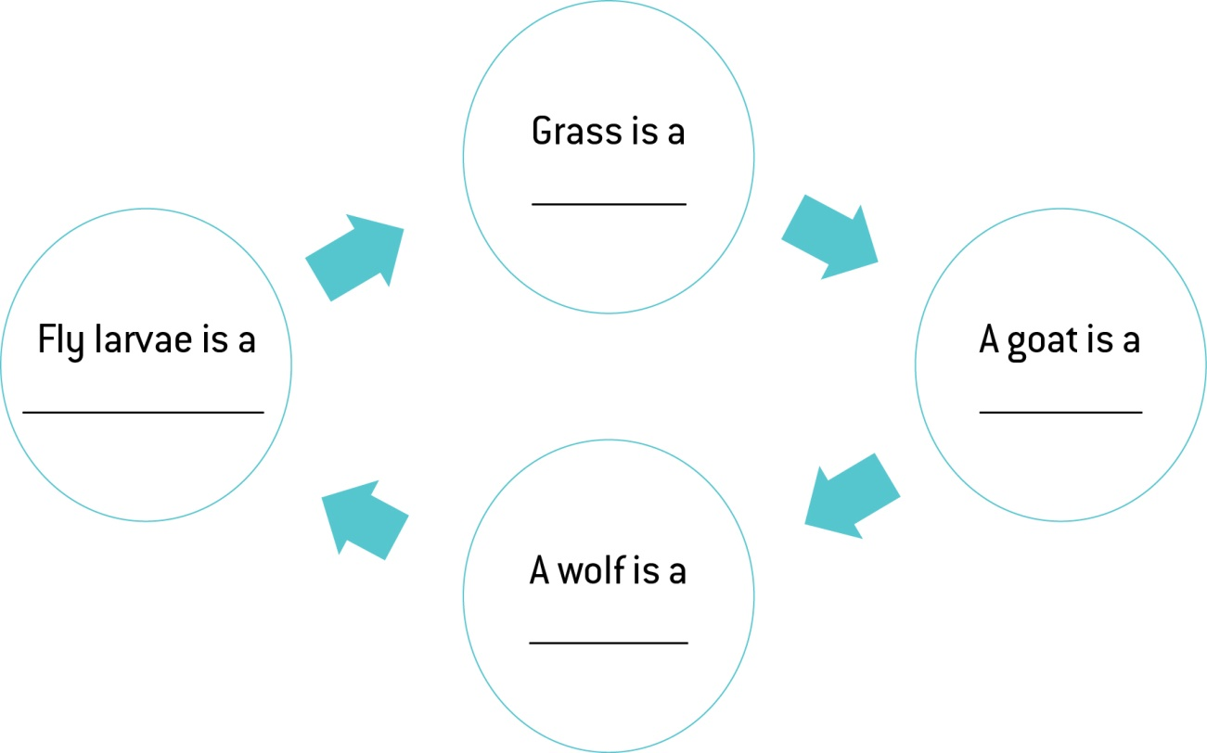

WORD DETECTIVE

**4** Secret message

Use words from the student book to work out the secret message below:

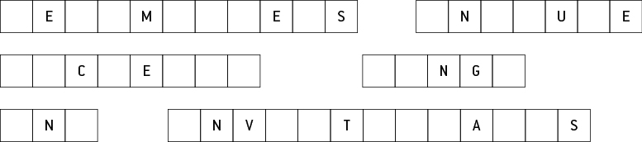

Literacy support worksheet

6.3 Food webs can be disrupted

Pages 106–107 and 200

Balance in the food web

1 The following observations were made last time I sat by a billabong:

• Nymphs, water beetles and fish were eating algae and water plants.

• Dragonflies were seen eating the water beetles and nymphs.

• European wasps were eating the nymphs and water beetles, and were attacking the dragonflies.

• A large black swan started feeding on the water plants, but also ate the nymphs and water beetles.

• A long-necked turtle also ate the water plants and water beetles.

• A huge wedged-tailed eagle swooped down and picked up the turtle from the water and started to eat it.

a Construct a food web from the information above. Draw the arrows from the European wasps in red.

|  |
| --- |
|  |

b What did the European wasps feed on?

c What would have normally eaten the organisms that the European wasps ate?

d Were there any predators of the European wasps?

e How do you think the European wasps may change the billabong in the future? (Hint: Which animals may be missing next time?)

2 If a frog eats 104 insects in one week, how many insects does it eat in:

a one month? ________________________________________________________

b one year? ________________________________________________________

c one day? _________________________________________________________

WORD DETECTIVE

3 Word search

Find the words listed, in the puzzle below.

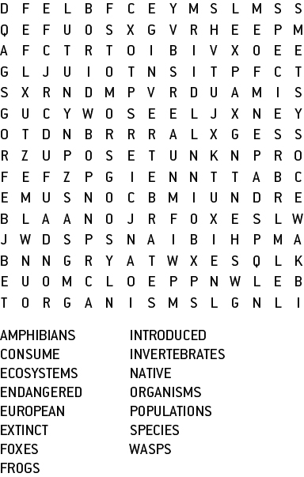



Literacy support worksheet

6.4 Human activity can affect local habitats

Pages 108–109 and 201

1 Label the diagram of the Amazon rainforest by completing the phrases below. Try to include more detail too.

• The trees have been cut down for…

• The land has been cleared for…

• The river is brown because…

• The burning trees cause…

• Pollution in this area comes from…

• The remaining habitat is under threat from…

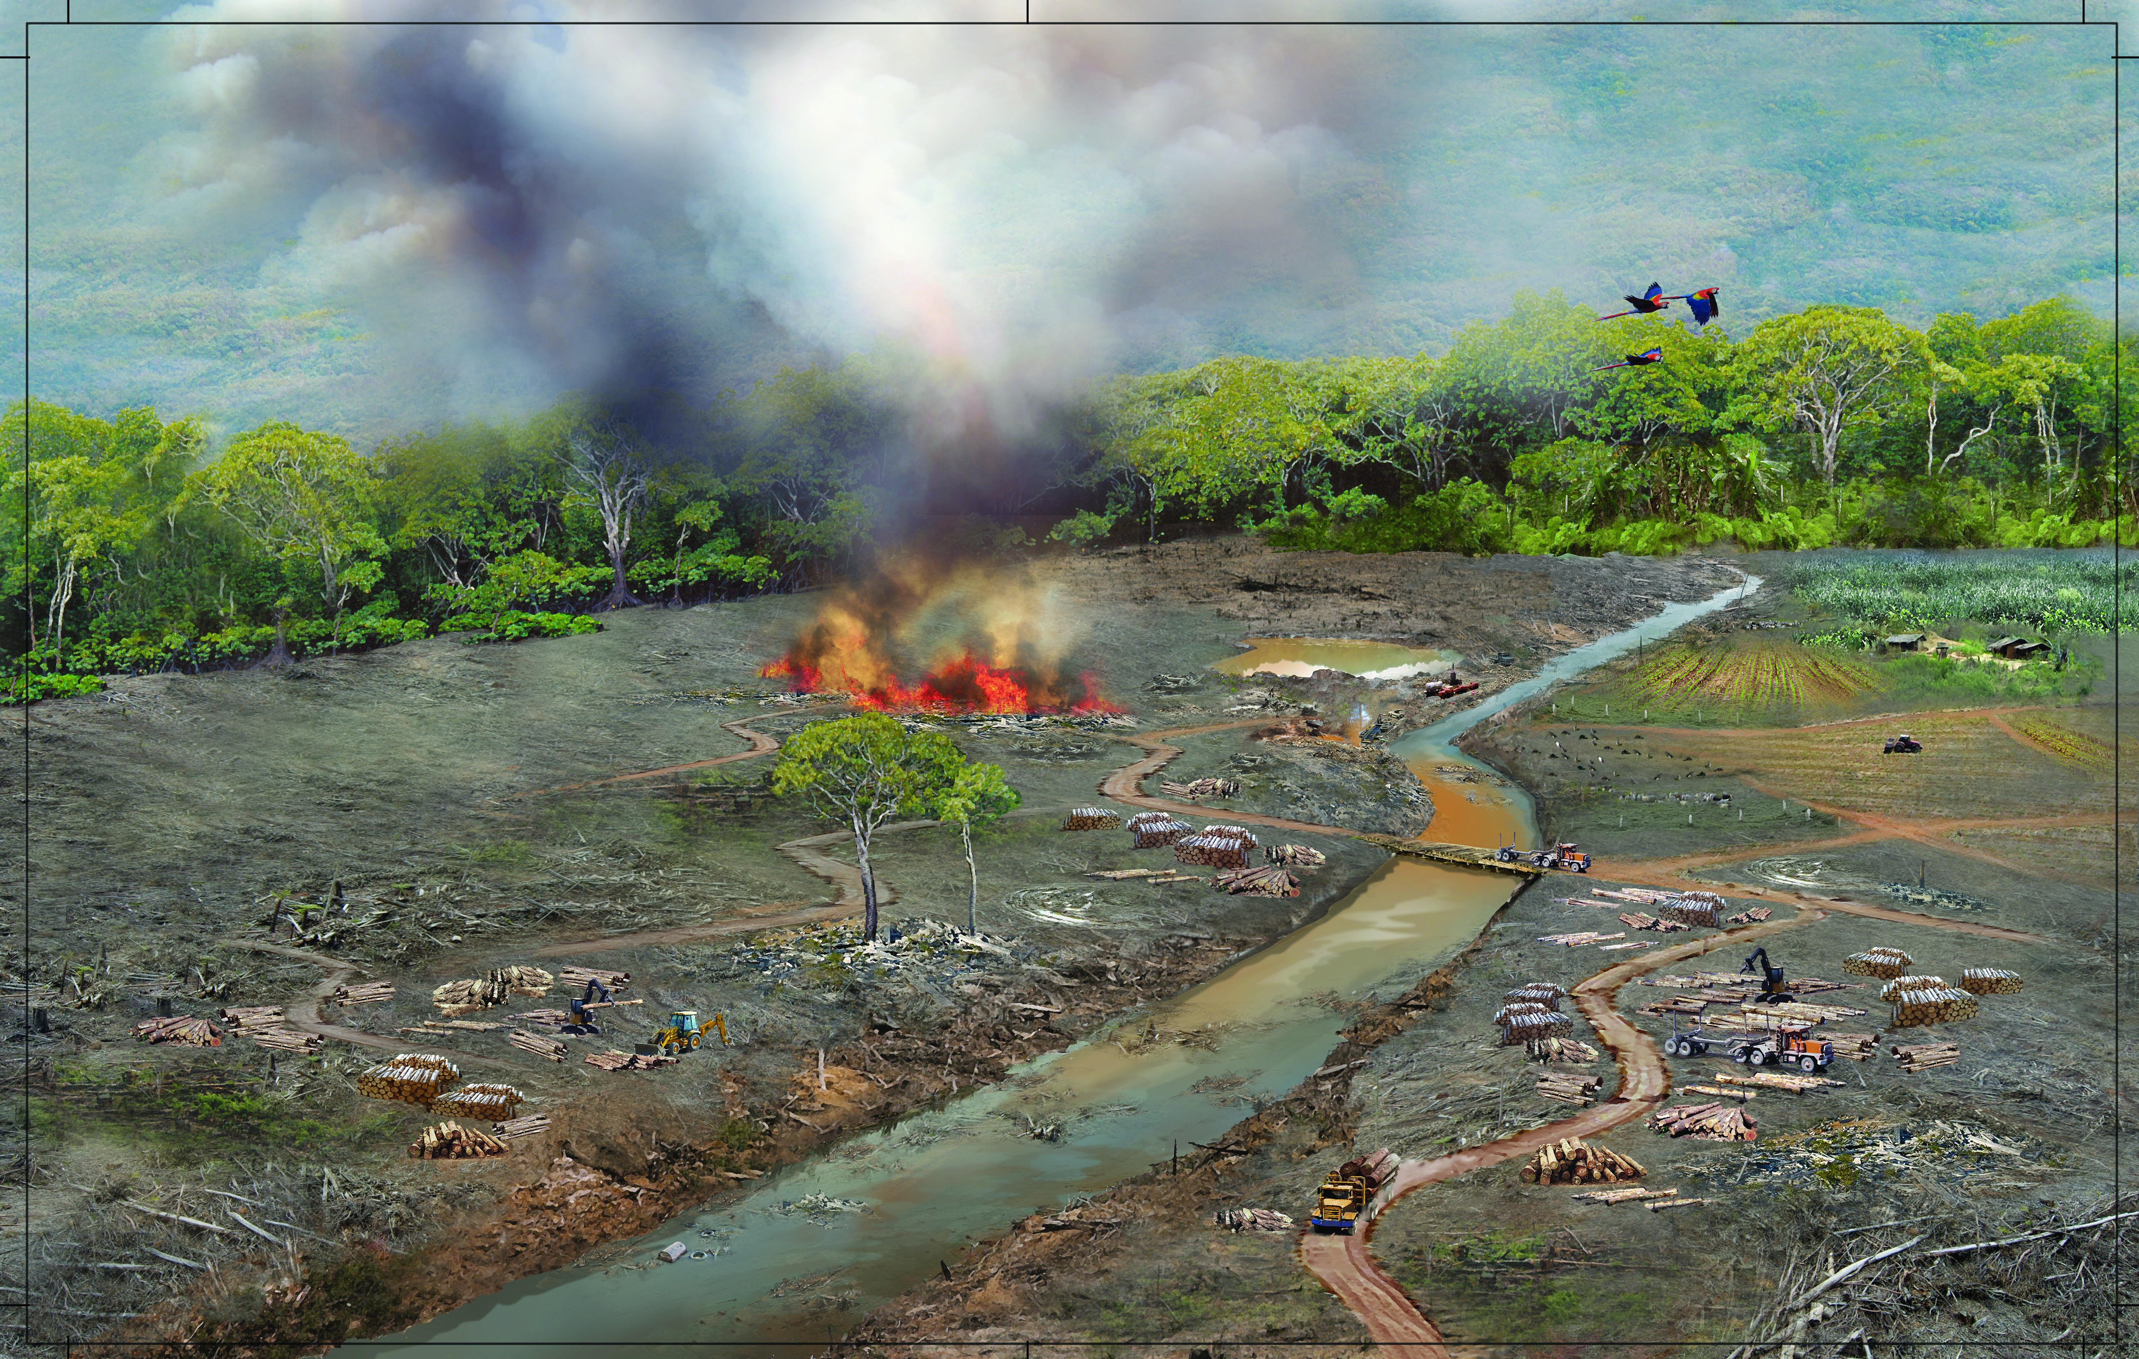

WORD DETECTIVE

2 Boggle

Find as many words as possible in the puzzle below.

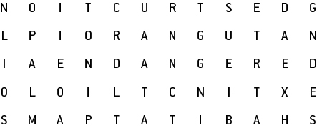

Literacy support worksheet

6.5 Isolated populations can be used as case studies

Pages 110–111

Isolated populations

1 As you can see from the photograph on the next page, Easter Island is not completely treeless. There are certain locations where trees have returned to the ecosystem.

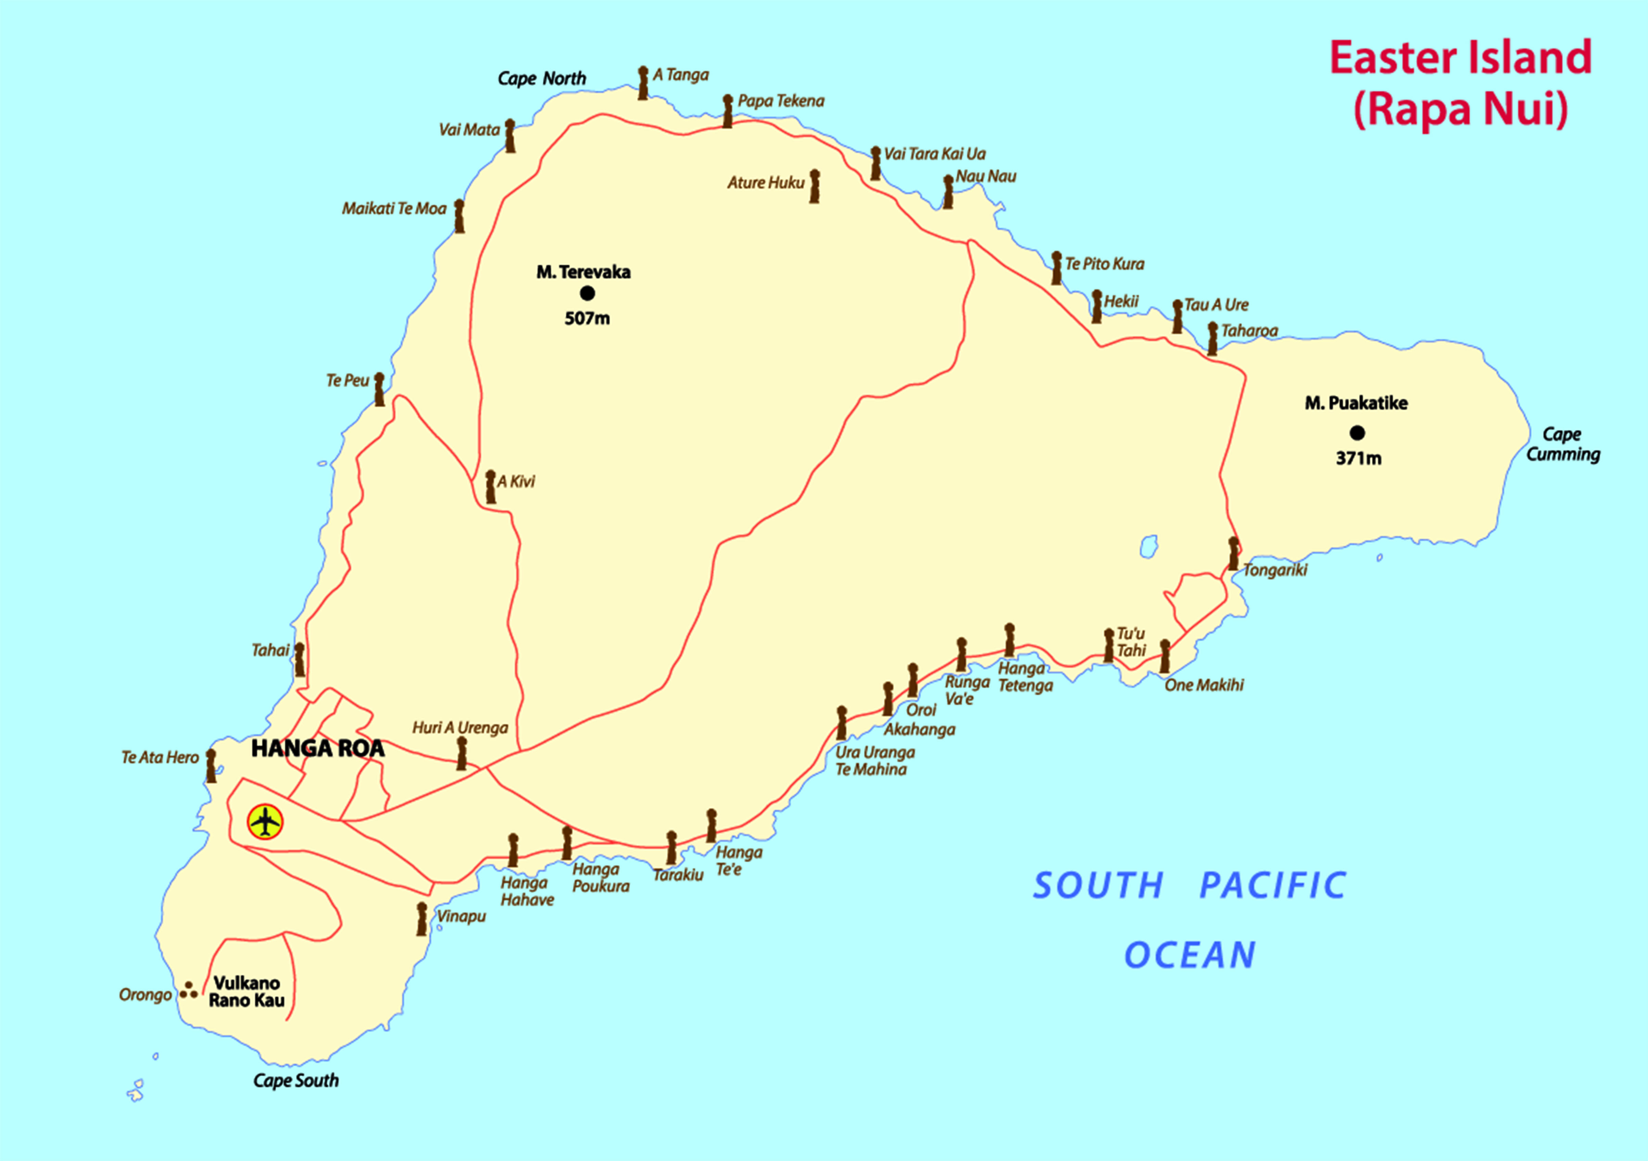

a Look carefully at the map below, especially near Hanga Roa. How can you tell that humans live on Easter Island?

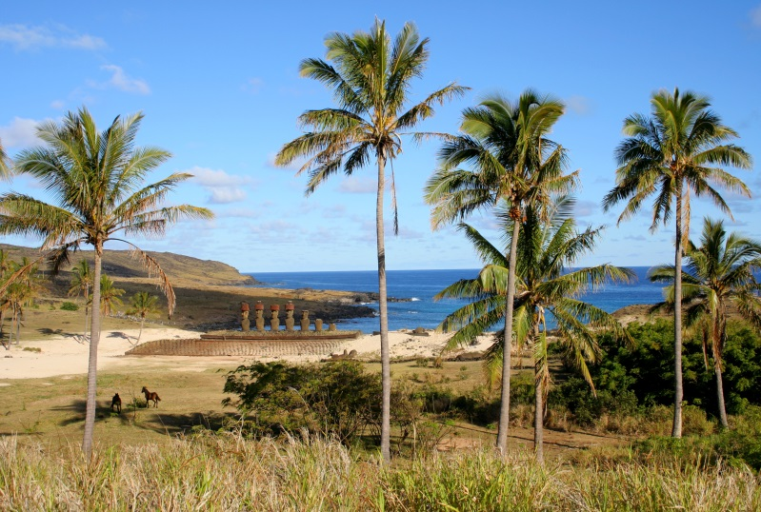b Can you think of any way these trees may have naturally returned to Easter Island?

WORD DETECTIVE

2 Match-a-word

Draw a line from the words to their meanings.

Civilisation Giant statues on Easter Island

Population Far away from other places

Moai The society and way of life in an area

Isolated People sent on a religious mission

Missionaries Meaning bare or unable to grow

Barren All the people who live in a particular place

Literacy support worksheet

6.6 Environments can be responsibly managed

Pages 112–113 and 201

Managing ecosystems

1 What are ‘green wedges’ or ‘green belts’?

2 a What are ‘green corridors’?

a Why are ‘green corridors’ important to animals and humans?

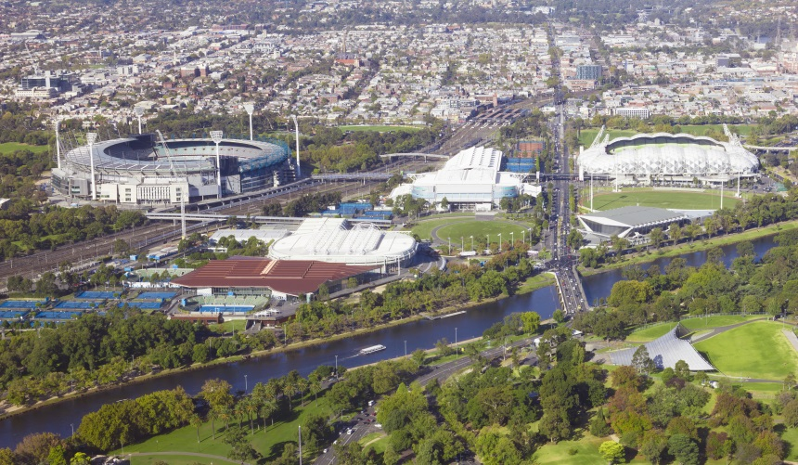3 Look at the picture of the ‘sporting precinct’ in Melbourne. Describe the benefits of this ‘green wedge’ to animals.

4 Why are National Parks so important?

5 What is a ‘seed bank’ or ‘seed vault’?

WORD DETECTIVE

6 Draw and label

a Apply your knowledge of ways to protect ecosystems by drawing and labelling a bird’s eye view diagram of your neighbourhood. Use the phrases below as some of your labels.

green belt green corridor green wedge

|  |
| --- |
|  |

b Describe where you have used the phrases above and why by completing the following sentences.

I designed a ‘green belt’ _________________________________________________________________

I designed a ‘green corridor’ ______________________________________________________________

I designed a ‘green wedge’ _______________________________________________________________

Literacy support worksheet

6.7 Modern land managers use traditional Indigenous techniques

Pages 114–115 and 202

Indigenous techniques for managing ecosystems

1 Fill in the positive and negative effects of the firestick farming practice of Indigenous Australians in the table below. Many of the positive effects can be found in the text.

|  |  |  |  |
| --- | --- | --- | --- |
| Effects of firestick farming on humans | | Effects of firestick farming on the ecosystem | |
| Positive (Hint: think about hunting and the effects on plants and animals) | Negative (Hint: think about the dangers of fire and pollution) | Positive (Hint: think about hunting and the effects on plants and animals) | Negative (Hint: think about ecosystems and the effects on animals) |
|  |  |  |  |

WORD DETECTIVE

2 Crossword

Use the clues to fill in the crossword.

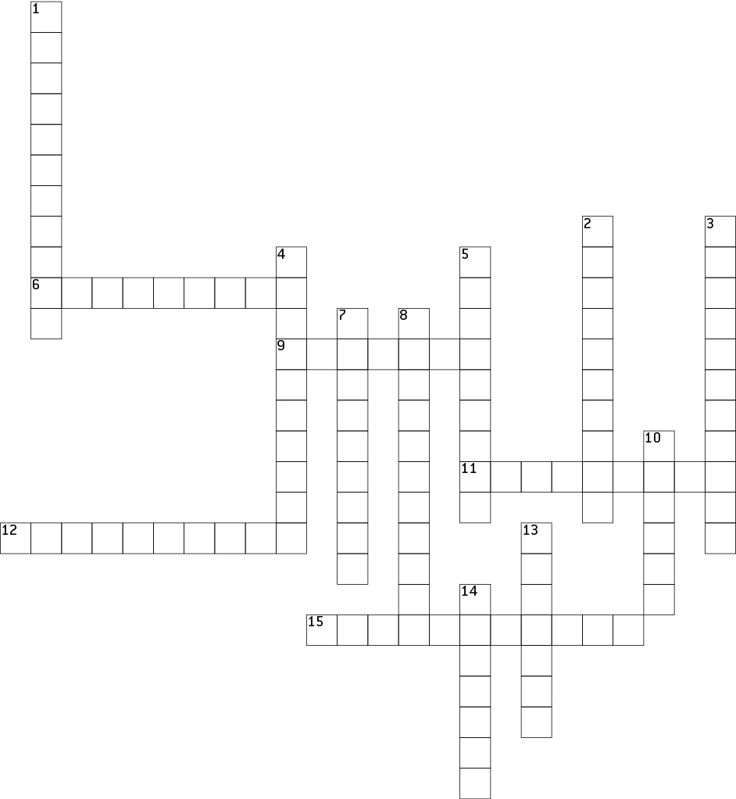

|  |  |
| --- | --- |
| **Across** | **Down** |
| 6 What can be seen of the land  9 In the right amounts, like weights on scales  11 Someone responsible for taking care of something  12 Originally from a particular place  15.Encouraging the growth of (e.g. food) | 1 Able to be kept going without damage  2 The dying out of an animal species  3 Part of a tradition  4 Animals that feed on plants  5 Controlled burning by Indigenous Australians  7 Easily set on fire  8 The surroundings or the natural world  10 A series of actions done in a certain order  13 Searching for and killing animals  14 Too much use (of the land, resulting in damage) |